Part 1:

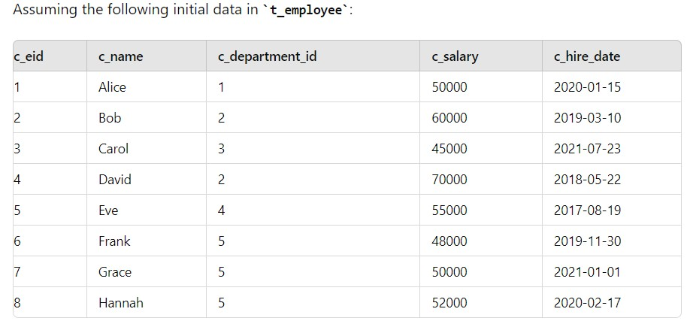

ALTER TABLE Questions:
1. Add a new column:
How would you add a new column c_email of type VARCHAR(100) to the t_employee table?
ALTER TABLE t_employee
ADD COLUMN c_email VARCHAR(100);
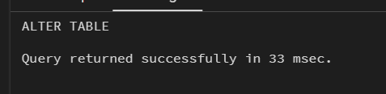
2. Modify a column type:
How would you modify the c_name column to increase the length to VARCHAR(100)?
ALTER TABLE t_employee
ALTER COLUMN c_name TYPE VARCHAR(100);

- Rename a column:
How would you rename the c_department_id column to c_dept_id?
ALTER TABLE t_employee
RENAME COLUMN c_department_id TO c_dept_id;
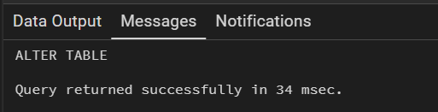
- Drop a column:
How would you remove the c_hire_date column from the t_employee table?
ALTER TABLE t_employee
DROP COLUMN c_hire_date;

- Set a default valu 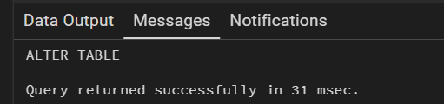e:
How would you set a default value of 0 for the c_salary column in the t_employee table?
- Add a unique constraint:
How would you add a unique constraint on the c_email column to ensure no two employees have the same email?
ALTER TABLE t_employee
ADD CONSTRAINT unique_employee_email UNIQUE (c_email);
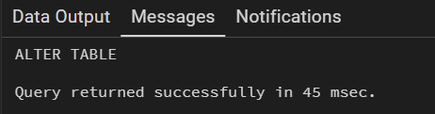
- Drop a unique constraint:
How would you drop the unique constraint on the c_email column if it was added?
ALTER TABLE t_employee
DROP CONSTRAINT unique_employee_email;
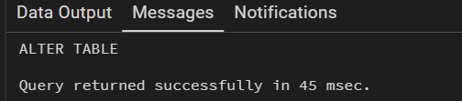
- Add a foreign key constraint:
How would you add a foreign key constraint on the c_department_id column, referencing a t_department table?
ALTER TABLE t_employee
ADD CONSTRAINT fk_employee_department
FOREIGN KEY (c_department_id)
REFERENCES t_department(deptid);
- Drop a foreign key constraint:
How would you drop the foreign key constraint on the c_department_id column?
ALTER TABLE t_employee
DROP CONSTRAINT fk_employee_department;
- Add a NOT NULL constraint:
How would you ensure that the c_name column does not accept NULL values?
ALTER TABLE t_employee
ALTER COLUMN c_name SET NOT NULL;
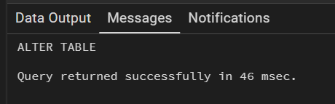
UPDATE Questions:
- Update a specific row:
How would you update the salary of 'Alice' to 55000?
UPDATE t_employee
SET c_salary = 55000
WHERE c_name = 'Alice';
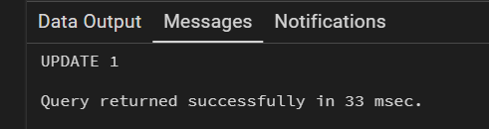
- Update multiple rows:
How would you increase the salary of all employees in department 5 by 5%?
UPDATE t_employee
SET c_salary = c_salary * 1.05
WHERE c_department_id = 5;
- Conditional update:
How would you set the c_hire_date to '2021-01-01' for all employees whose salary is less than 50000?
UPDATE t_employee
SET c_hire_date = '2021-01-01'
WHERE c_salary < 50000;
- Update with a JOIN:
How would you update the c_department_id for all employees based on a t_department table where department names match?
UPDATE t_employee e
SET c_department_id = d.deptid
FROM t_department d
WHERE e.c_department_name = d.deptname;
- Set NULL value:
How would you set the c_hire_date to NULL for all employees hired before '2018-01-01'?
UPDATE t_employee
SET c_hire_date = NULL
WHERE c_hire_date < '2018-01-01';
- Update with a subquery:
How would you increase the salary of employees by 10% if their salary is less than the average salary of all employees?
UPDATE t_employee
SET c_salary = c_salary * 1.10
WHERE c_salary < (SELECT AVG(c_salary) FROM t_employee);
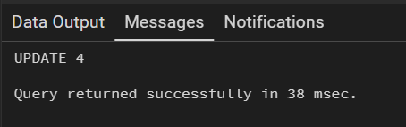
RENAME Questions:
- Rename a table:
How would you rename the t_employee table to t_staff?
ALTER TABLE t_employee
RENAME TO t_staff;
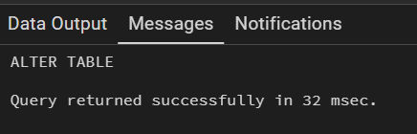
- Rename a constraint:
How would you rename a primary key constraint on the c_eid column to pk_employee_id?
ALTER TABLE t_employee
RENAME CONSTRAINT t_employee_pkey TO pk_employee_id;
- Rename a sequence:
How would you rename the sequence for the SERIAL column c_eid if it was named t_employee_c_eid_seq?
ALTER SEQUENCE t_employee_c_eid_seq
RENAME TO t_staff_c_eid_seq;
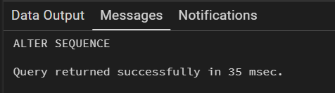
DELETE Questions:
- Delete a specific row:
How would you delete the row of the employee named 'David'?
DELETE FROM t_employee
WHERE c_name = 'David';
- Delete with a condition:
How would you delete all employees from department 4?
DELETE FROM t_employee
WHERE c_department_id = 4;
- Delete all rows:
How would you delete all rows from the t_employee table but keep the table structure intact?
DELETE FROM t_employee;
- Delete using a JOIN:
How would you delete all employees who belong to a department that has been removed from the t_department table?
- Delete with a subquery:
How would you delete employees whose salary is below the average salary of all employees?
DROP TABLE Question:
- Drop the table:
How would you drop the t_employee table, ensuring that it no longer exists in the database?

Part 2:
- Basic Queries:
  - Select all employees
  - Find employees who earn more than 50,000
  - List all employees from a specific department (e.g., department 2)
  - Find employees hired after January 1st, 2020
  - Find employees with the same salary
  - Find employees whose name starts with 'A'
  - List employees whose salary is between 45,000 and 60,000
  - Find employees hired between two dates
  - Find employees who earn the same as or more than the average salary
  - Find employees hired more than 5 years ago
  - Find all employees who were hired on a Monday
  - List employees and their hire year
- Aggregations:
  - Get the total number of employees
  - Calculate the average salary of all employees
  - Get the highest salary in the company
  - Get the minimum salary in the company
  - Find the total salary cost for a specific department (e.g., department 5)
  - Get the total salary of employees hired after 2020
  - Find the second-highest salary
- Grouping and Sorting:
  - Group employees by department and find the total salary per department
  - Count the number of employees per department
  - Get the department with the highest total salary
  - List employees ordered by hire date (oldest first)
  - List employees ordered by salary in descending order
  - Find employees with a salary higher than the average salary in their department
- Conditional Operations:
  - Get employees who were hired between two dates and have a salary above a certain threshold
  - Find employees whose salary is below the average salary and were hired after a specific date

